# MGMT 443 Concept Testing

## Concept testing: definition and purpose

* Research on the concept may begin with qualitative research procedures
  + A focus group in which consumers react to the idea in a moderated, but free-form discussion
  + Produce both a sales volume forecast and diagnostic information to guide the positioning in the marketplace

## Executing a concept test

* Concept test
  + Concept communication method
  + Consumer response measured
* Communication
  + Factual, none emotional way
    - Advantage
      * Eliciting evaluation of the concept rather than the concept plus communication strategy
    - Disadvantage
      * Consumer is reacting to something quite unlike that which he will see in the marketplace
  + Persuasive communication
    - Better behavioral predictions from consumers since there is a greater similarity to the actual purchase situation

|  |  |  |
| --- | --- | --- |
|  | Factual | Persuasive |
| Words only |  |  |
| Visual only |  |  |
| Words + Visual |  |  |

* Move from factual to persuasive tone increases purchase intent scores
* Words plus visual generally produces scores greater than either alone
* Data type
  + Intended purchase measures
  + Overall product diagnostics
  + Special attribute diagnostics
  + Respondent profiling variables

### Purchase measure

* Purchase intention
  + Included in virtually all concepts tests
* Expected frequency
* Based on this product description, how likely would you be to buy this product if it were available at a store in your area, check one
  + Definitely would buy
  + Probably
  + Might or might not
  + Probably would not buy
  + Definitely would not buy
* For nondurable goods
  + Frequency is a key
  + Scale
    - Once a week or more often
    - Once every two or three weeks
    - Once a month
    - Once every two to three months
    - Once every four to six months
    - Once or twice a year
    - Less often
    - Never
* Sales volume per household in time period = % households in market who try
  + Expected # purchases in the period for triers
  + Expected # units per purchase

### Overall product diagnostics

* Two types
  + A set devoted to the overall idea
  + A set on specific attributes
* Address the concept
  + Uniqueness or differentiation from other products
  + Believability
  + Importance in solving a consumer’s problem
  + Inherent interest
  + Value for the money
* Uniqueness and believability are the most widely used measure
* If concept statement includes the price at which the product will be offered, a measure is usually taken on the relative size of the benefits
  + Usually done in a value-for-the-money question measured on a five-point scale

### Specific attribute diagnostics

* Useful to prove which attributes/benefits contribute to the purchase intention
  + this probing is achieved through the use of open-ended questions
  + it is often useful to collect data on perceptions of specific attributes and their importance to the consumer
* quadrant analysis

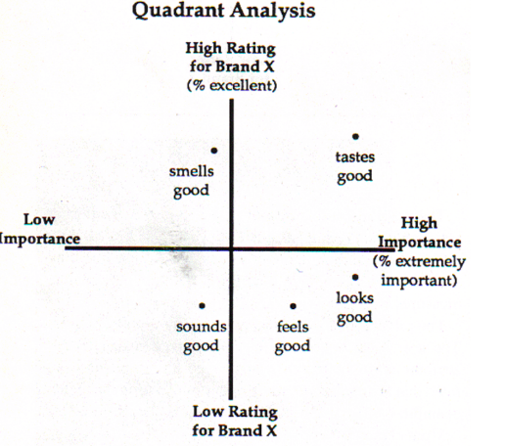

* quadrant 1
  + suggests the concept is good on the wrong things
* quadrant 2
  + the set of key communication attributes
  + both important and the product does well on them
* quadrant 4
  + the problem quadrant where one should focus product improvement efforts as they are salient to the consumer and the concept currently is viewed poorly on them

### Respondent profiling variables

* useful in analyzing concepts is the type of consumers who respond in different ways
* help in targeting efforts but other more innovative data collection can e useful
  + current purchase behaviour
  + perception of the category
  + barriers to changing brands
  + influence in actual purchase decision

## Interpreting the purchase intend data

* Purchase intent score is at the heart of a concept
* The variation in scores across categories shows the need to have category specific norms
  + Published sources
  + The company’s won files
  + The files of the research company hired to do the concept test
* One of the major concept testing research firms uses its extensive data base built up from its past tests as its primary competitive advantage

## Relationship between intent and actual purchase

* With respect to sale volume estimation, research shows that there is a strong correlation between purchase intention and trial
  + Concept with higher PI scores than benchmarks tend to have higher trial rates
* The rule-of-thumb
  + Top-box is a good indicator of the likely trial rate
* Their test involves a finished product in a finished package rather than a concept statement
* PI is a predicator only of trial and not repeat purchase